#include <stdio.h>

// Global loop variables
int i, j, k;

// Function to merge two subarrays
void merge(int a[], int lb, int mid, int ub)
{
// Calculate the sizes of two subarrays to be merged
int n1 = mid - lb + 1;
int n2 = ub - mid;

// Create temporary arrays to hold the values
int L[n1], R[n2];

// Copy data to temp arrays L[] and R[]
for (i = 0; i < n1; i++)
L[i] = a[lb + i];

for (j = 0; j < n2; j++)
R[j] = a[mid + 1 + j];

// Merge the temp arrays back into a[lb..ub]
i = 0; // Initial index of first subarray (L)
j = 0; // Initial index of second subarray (R)
k = lb; // Initial index of merged subarray

while (i < n1 && j < n2)
{
if (L[i] <= R[j])
a[k++] = L[i++];
else
a[k++] = R[j++];
}

// Copy the remaining elements of L[], if any
while (i < n1)
a[k++] = L[i++];

// Copy the remaining elements of R[], if any
while (j < n2)
a[k++] = R[j++];
}

// Recursive Merge Sort function
void mergeSort(int a[], int lb, int ub)
{
if (lb < ub)
{
int mid;

// Same as (lb + ub) / 2, but avoids overflow
mid = lb + (ub - lb) / 2;

// Sort first and second halves recursively
mergeSort(a, lb, mid);
mergeSort(a, mid + 1, ub);

// Merge the sorted halves
merge(a, lb, mid, ub);
}
}

// Function to print the array
void printArray(int a[], int n)
{
for (i = 0; i < n; i++)

printf("%d ", a[i]);

printf("\n");
}

int main()
{
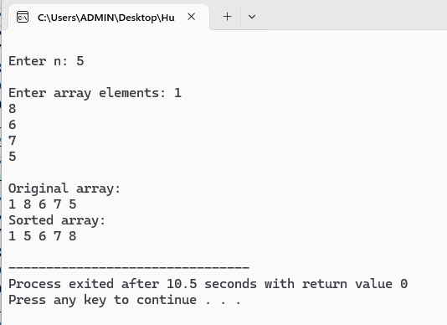
int a[100], n;

// Input the number of elements
printf("\nEnter n: ");
scanf("%d", &n);

// Input array elements
printf("\nEnter array elements: ");
for (i = 0; i < n; i++)
scanf("%d", &a[i]);

// Print the original array
printf("\nOriginal array:\n");
printArray(a, n);

// Call merge sortN
mergeSort(a, 0, n - 1);

// Print the sorted array
printf("Sorted array:\n");
printArray(a, n);

return 0;
}

